Object Oriented Programming

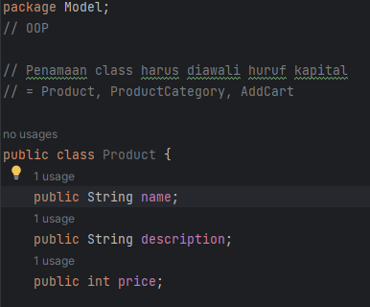

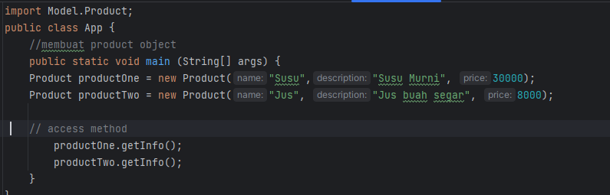

Object yang sudah dibuat

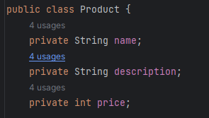

Setting Private

Perlu Metode Setter and Getter

Objek perlu ditambahkan set dan get

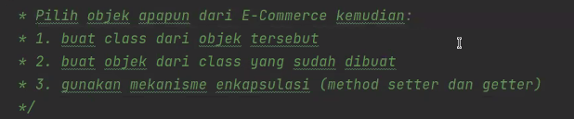

Tugas OOP



